
CS 111L – Programming Fundamentals
Lab # 09
System & Pre-Defined Functions

––
Student Name: Athar Imran
Student ID: 2604277

Assignment Date: 10 Nov, 2026
Assignment done: 11 Nov, 2026
Due Date: 12 Nov, 2026

Contents
Part 1: System-Defined String Functions 3
1. Declare an Empty String and Print Its Size 3
2. Initialize a String with Your Name and Print It 3
3. Print the Length of a User-Input String 3
4. Print Capacity Before and After Appending Text 3
5. Display Maximum Possible String Size 4
6. Concatenate First and Last Name Using += and append() 4
7. Extract the First Word from a Sentence 5
8. Search for a Keyword and Print Its Index 5
9. Reverse a String Entered by the User 6
Part 2: Predefined String Functions 7
10. Print Length of a User-Input Character Array 7
11. Copy a String into Another Character Array 7
12. Concatenate Two Character Arrays Safely 8
13. Compare Two Strings and Print Which Is Lexicographically Smaller 8

Part 1: System-Defined String Functions

1. Declare an Empty String and Print Its Size
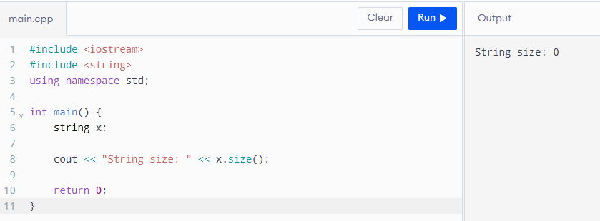

2. Initialize a String with Your Name and Print It
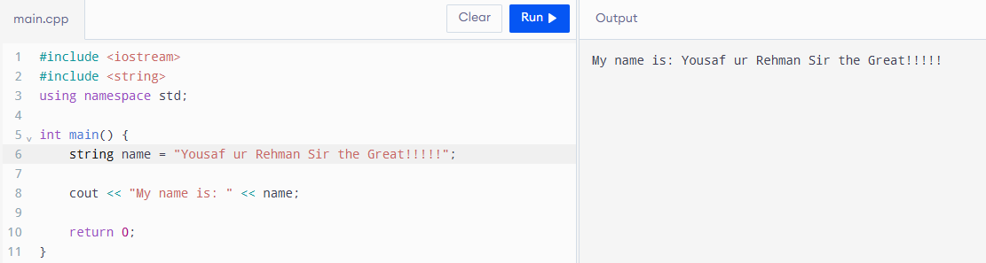

3. Print the Length of a User-Input String
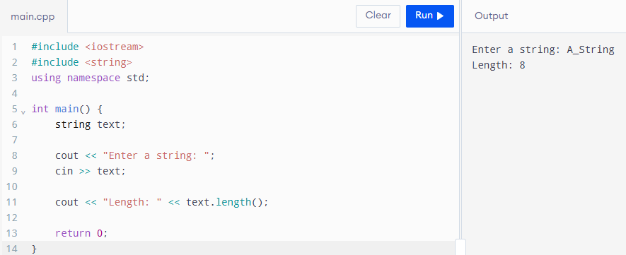

4. Print Capacity Before and After Appending Text

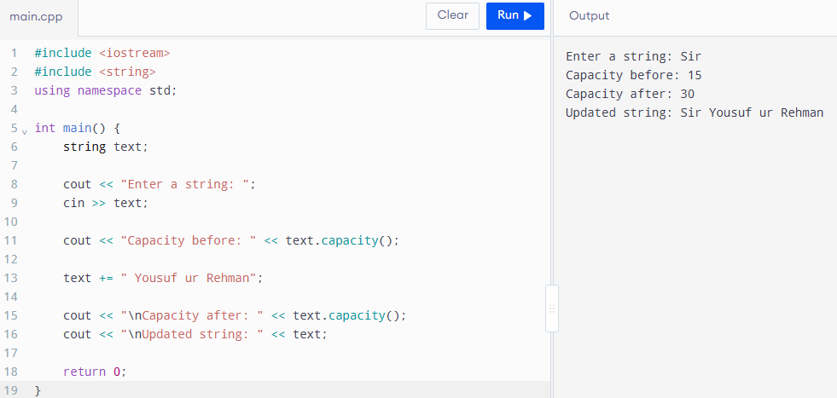

5. Display Maximum Possible String Size
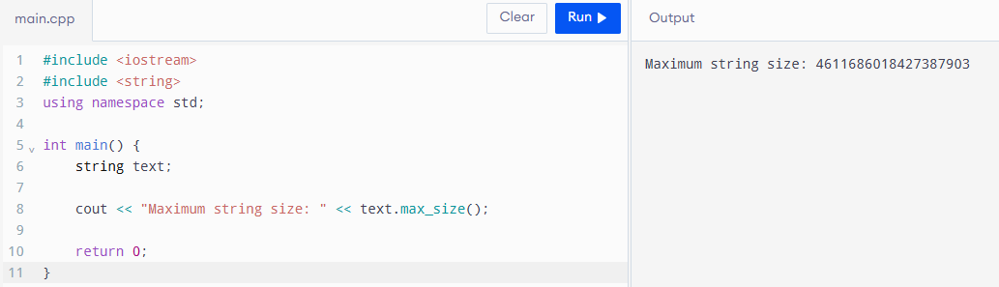

6. Concatenate First and Last Name Using += and append()
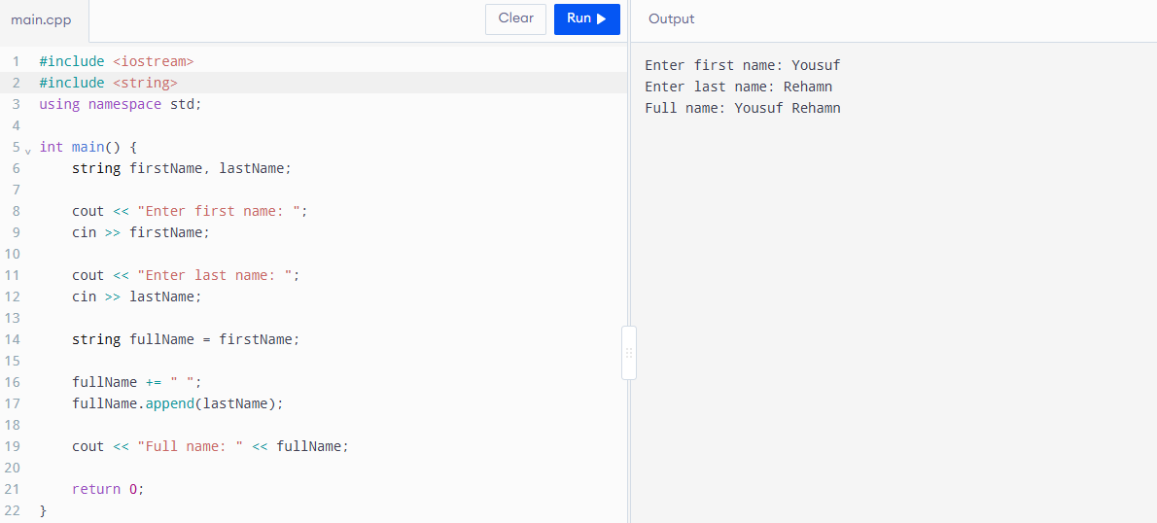

7. Extract the First Word from a Sentence
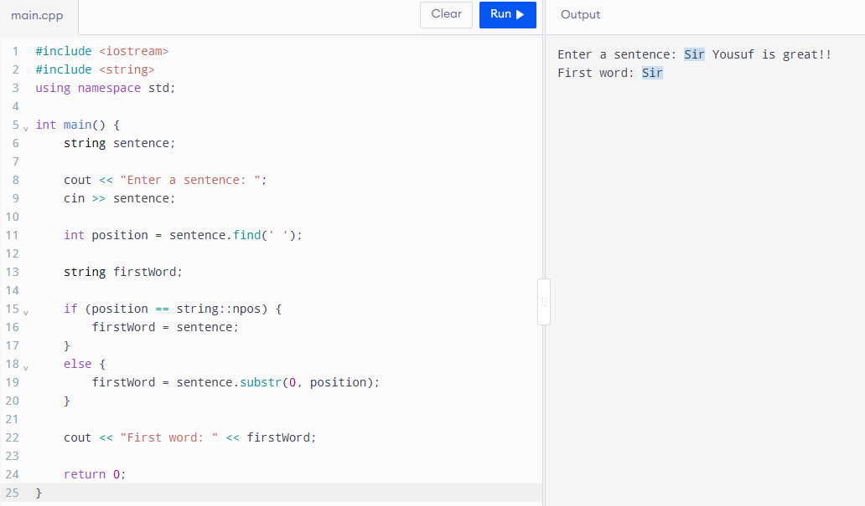

8. Search for a Keyword and Print Its Index
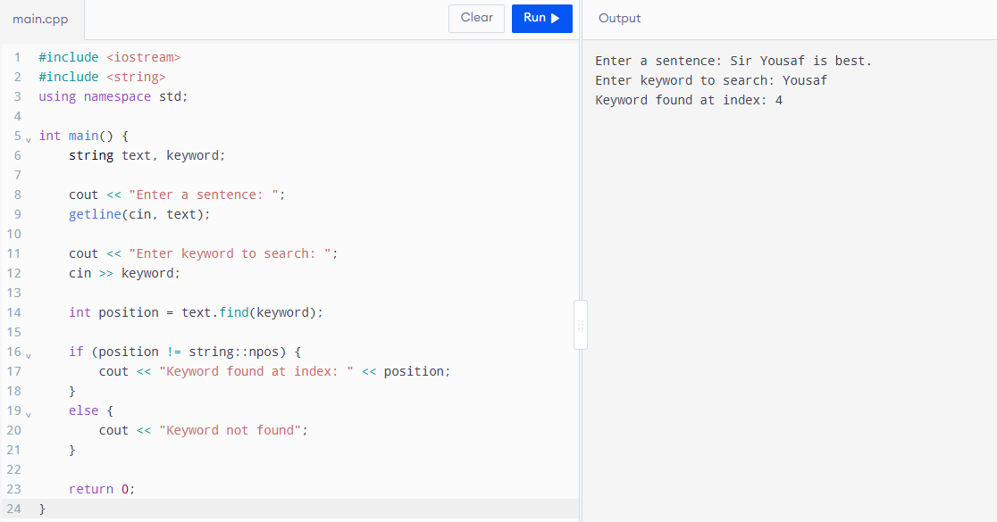

9. Reverse a String Entered by the User
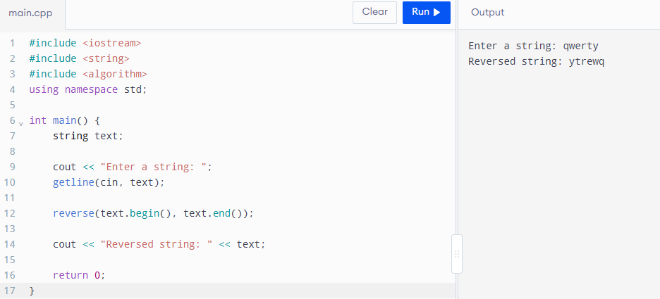

Part 2: Predefined String Functions

10. Print Length of a User-Input Character Array
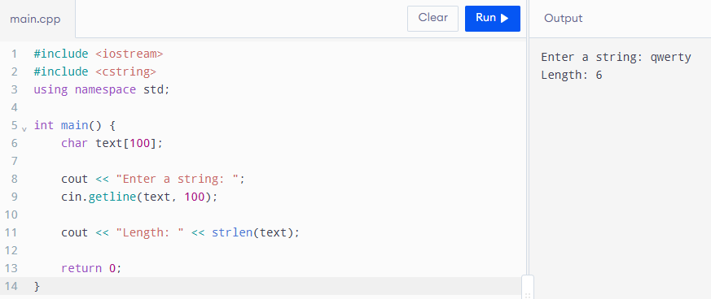

11. Copy a String into Another Character Array
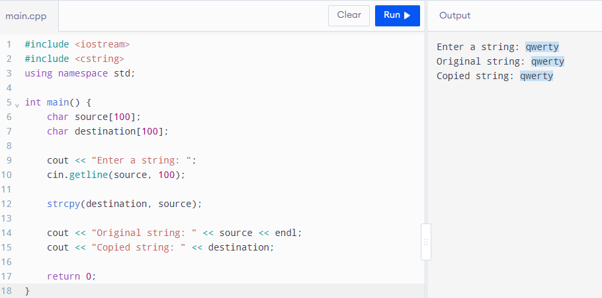

12. Concatenate Two Character Arrays Safely
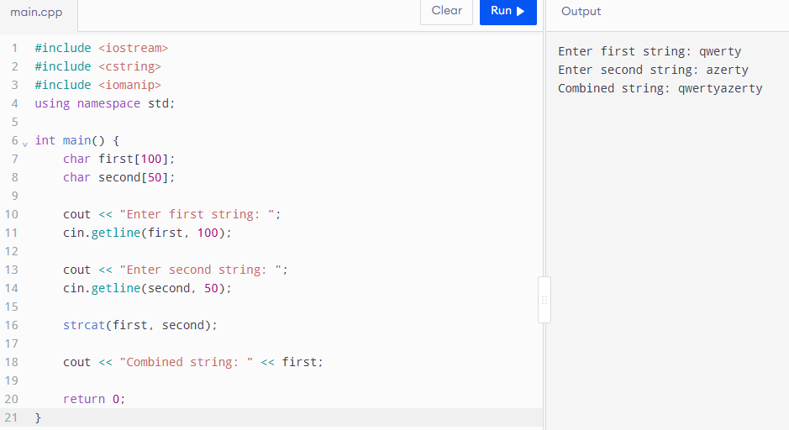

13. Compare Two Strings and Print Which Is Lexicographically Smaller


